 | Stage Management: Tools
A welcoming theatre community with a passion for creating vibrant, engaging entertainment
The following are supplementary forms and templates specific to Stage Managers. These were previously part of the Stage Management Handbook. Other documents (such as Harassment and Discrimination Policy) are not compiled here, as other personel need access to them and wouldn’t know to look here. You’ll either be given a printed or digital copy of these additional documents. All of these will also be accessible from our website under Handbooks and Policies.
These are roughly sorted into: Templates, Examples, Other.
When updating or making any document, be sure to include room for the date.

Templates
Production Technical Requirements - A summary of technical requirements. For your own reference.
Rehearsal Schedule - Posted so actors know when they’re needed and for what section. Must be kept up to date.
Rehearsal Report - Used to communicate with the production team about requests of demands. Filled out as needed, but sent to all on the production team.
Cue Sheet Summary - A summary of all the lighting, sound, projections, and curtains
Show Report - A digital link, to be completed after every performance.
Incident Report - Used to inform GM about “incidents” such as injuries, medical issues, harmful communications, or anything else that may need followup. When in doubt, fill it out.

Examples
Scene Breakdown Chart - Which characters are needed in which scenes
Attendance Sheet - To keep track of actor arrivals
Blocking Notes - A single page example of how to record actor movements
Preset and Scene Change Schedule - Tracking of how the set needs to be changed
Light and Sound Cue List - Summary of technical cues.
Prompt Book Cues (Recommend to print this page in colour) - A single page example of how cues are entered into the Prompt Book
SM Checklists (Preshow, Intermission, Postshow) - Example of what the Stage Manager has to do before, between, and after acts.

Other
The Rehearsal Schedule - One of the most important parts of SMing is letting people know when they’re needed and for what. This reiterates that.
Opening and Locking Up Information - How to lock up the theatre.
The Prompt Book - A non-exhaustive list of what needs to be in the Prompt Book
Stage Crew Guidelines and Information Sheet - A guide when talking to Stage Crew about what is expected of them.
PRODUCTION TECHNICAL REQUIREMENTS

ACT / SCENE / PAGE | SET | LIGHTING | COSTUMES / MAKEUP | PROPS | SOUND | SPECIAL EFFECTS

REHEARSAL SCHEDULE
Updated on [DATE]
Tuesdays & Thursdays from 7 to 10; Sundays 1-5 unless otherwise noted
Langham Rehearsal Room until __________ / Onstage as of _______________

Date & Time | What is planned | Who is needed | Unavailable

REHEARSAL REPORT
DATE: __________________ LOCATION: _______________________

PROPERTIES: | SET/SCENERY:
COSTUMES: | FITTINGS:
SOUND: | LIGHTS:
SCHEDULE: | THEATRE/BUILDING:
REHEARSAL NOTES: | MISCELLANEOUS:

CUE SHEET SUMMARY

Pg | Cue | What | When | Notes

SHOW REPORT
Please use the link below to fill out information about the performance. The GM, Director, Head Scenic Carpenter, and TD receive this report. For simplicity, you may want to bookmark this link.

Please fill in the show report nightly, especially if there are things (set or safety) that must be dealt with before the following rehearsal. The sooner this report goes out, the more time there is for the fix to be made.

Stage Manager Show report

Or

https://tinyurl.com/y65c9o94

INCIDENT REPORT
Langham Court Theatre
805 Langham Court, Victoria, BC

Date of Incident: | Time of Incident:
Reported by (Name/Position): | Phone # of Reporter:
Location of Incident:

Details of Incident:
If there was an injury, please describe details of injury:
Name of attending health professional (if applicable):
Describe action or steps taken at time of Incident:
Witnesses (Name(s) / Phone Number(s):

EXAMPLES:
SCENE BREAKDOWN CHART

ACT ONE

CHARACTER | Sc. 1  Pgs  1-8 | Sc. 2  Pgs  9-12 | Sc. 3  Pgs  13-19 | Sc. 4  Pgs  20-22 | Sc. 5  Pgs  23-30 | Sc. 6  Pgs  31-35 | Sc. 7  Pgs  36-46 | Sc. 8  Pgs  47-49 | Sc. 9  Pgs  50-53
Bashful |  | x | x | x | x |  | x
Doc | x | x |  | x | x | x | x | x
Dopey |  | x |  |  | x | x | x |  | x
Grumpy | x | x |  | x | x | x | x | x | x
Happy | x |  | x |  | x |  | x |  | x
Sleepy |  |  |  |  | x |  | x | x | x
Sneezy | x | x |  | x | x | x | x | x
Snow White |  |  | x | x | x
Wicked Witch | x | x | x

X denotes that the character is in the scene

ATTENDANCE SHEET

Updated on [insert DATE]

 | Phone # | TUES  Jan 2 | THURS  Jan 4 | TUES  Jan 9 | SUN  Jan 14 | TUES  Jan 16 | SUN  Jan 21
Drew |  |  |  | X
Jean
Jim |  |  |  | X
Danda
Wendy |  |  | X | X |  | X | X
Corinna
Alec |  | X |  | X
Phil |  | X | X | X | X
Topsy |  | X | X | X | X | X | X

X indicates not scheduled for this rehearsal / performance

BLOCKING NOTES
Ask other SMs if they would be willing to lend their Prompt Books from previous shows for more examples.
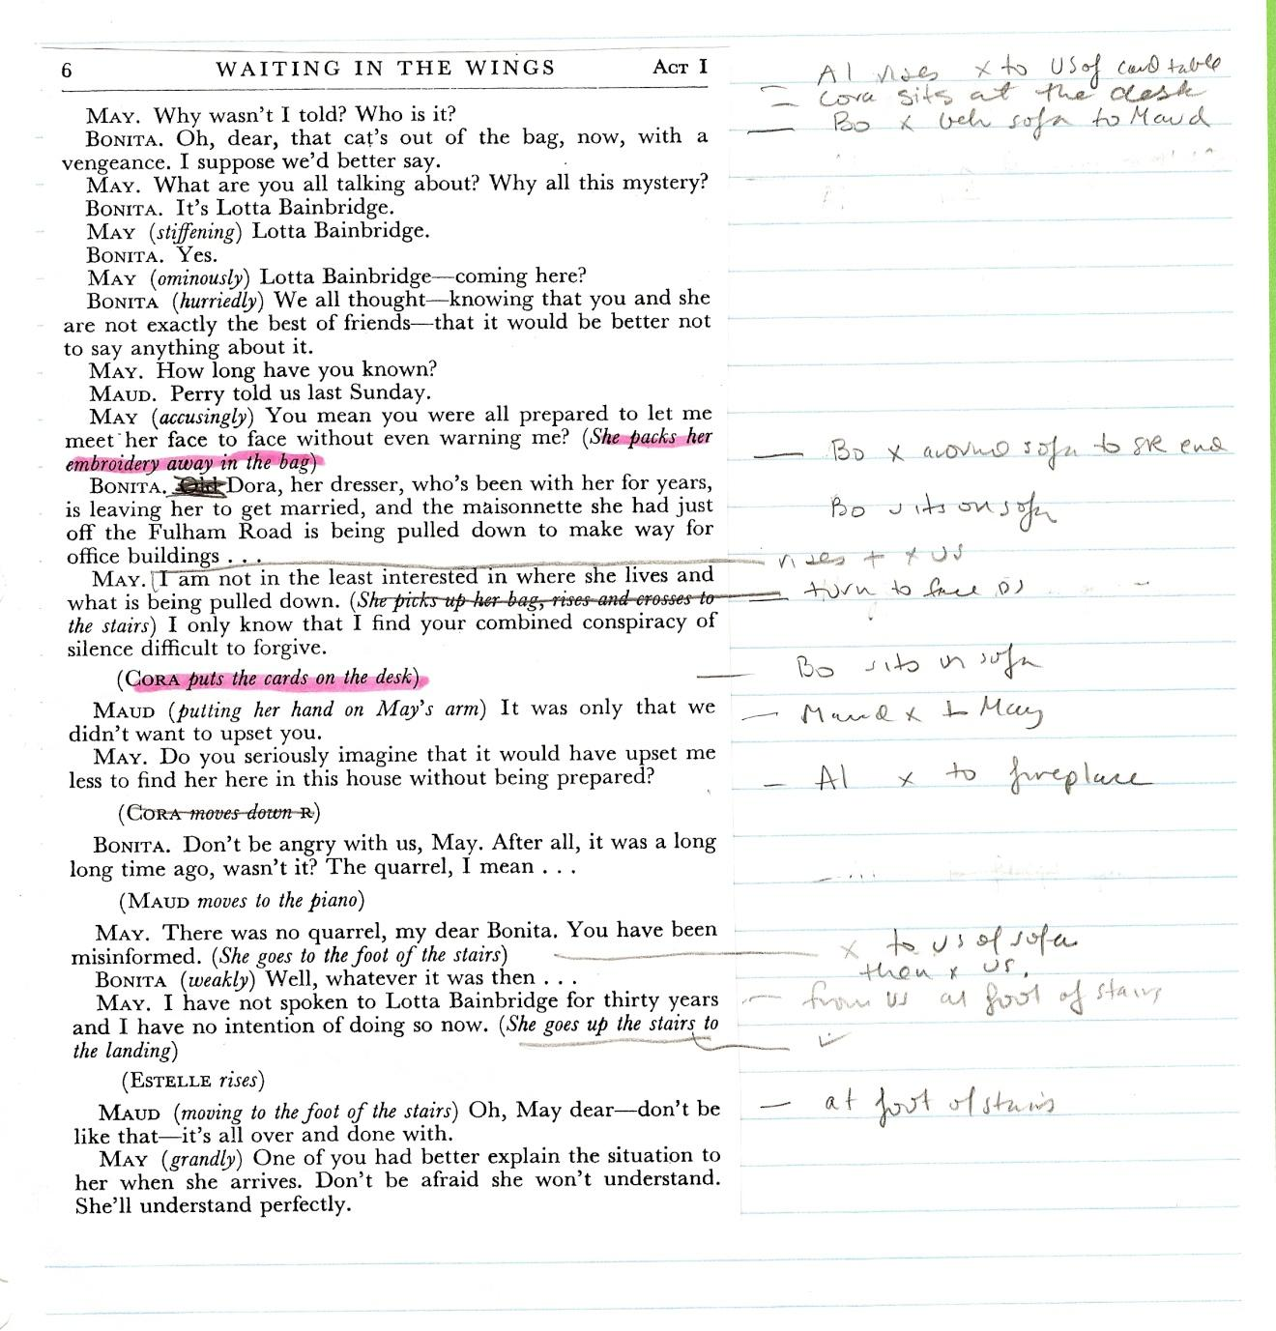

PRESET AND SCENE CHANGE SCHEDULE

PERSONALS:
John and Halbrech should be wearing watches
John needs to have items pre-placed in his jacket:
- Envelope of “cash” / Newspaper article / Notepad and pen

PRE SHOW
Scrim in
Iceberg in closed position
Door panels at SR and SL open against stage walls
Deck chair in DS position (DS of iceberg) (footrest attached to front but not extended)
Check offstage projector cable – in coiled position
Video camera on wall USC is turned ON -- CREW
Light haze on stage just prior to house in – FOG MACHINE

7:55 Ship horn
John gets into place in deck chair / Halbrech gets into place inside iceberg
8:00 Pre show speech
Sound of ship followed by crash into iceberg - SCRIM OUT
Morse code and iceberg cracking sound – ICEBERG OPENS

ACT ONE
SCENE ONE - END OF SCENE:
John: When does she come in?
Halbrech: Now.
Scene transition:
Sound Q – edgy music (#24)
Projection on USL – Titanic
Kaspar and Dane move deckchair to US position (footrest on but not extended)
Scene lights

SCENE SEVEN - SCENE IS VERY VERY SHORT!!!
Halbrech: We’re giving her the day off. After which you have twenty-four hours.

SCENE TEN - END OF SCENE:
Winifred: Astor. … Astor … SCREAMS … Ice.
BLACKOUT
Sound Q: Phillip Glass – about 15 seconds
Actors exit
Intermission lights and music

INTERMISSION
CREW:
- turn camera on wall US back ON
- plug in power for projector
KASPAR & DANE:
- strike suitcase, briefcase
- ice cubes that are DS of riser and under cart etc. – put in ice bucket DSR

ACT TWO
SCENE NINE - END OF SCENE:
Halbrech: Keep her locked up. We’ll be back in a few hours. … There are others.

Scene transition:
Halbrech exits DSR
Sound Q: Foghorn
Projection USC – Captain Smith
Kaspar/Dane move deck chair to DS position
Kaspar/Dane attach footrest in non-extended position
CREW – turn off video camera on wall USC
Scene lights

SCENE TEN
John is seated on deck chair
Winifred enters from US “bedroom” with hair down

FOG MACHINE: FOG to start on page 45 – see reference to ship sound Q

END OF SCENE:
Hold my hand! Hold my hand! We’ll go up, we’ll go up, we’ll go all the way up Scotland Road. …

Crew at DSR and DSL open DS doorframes
Kaspar/Dane move iceberg to closed position

John: When does it come?
Winifred: Now.

Sound Q: sound of iceberg, Morse code SOS
Sound Q: Heart monitor going into flatline

POST SHOW
- Re-attach scrim
- Turn off fog machine – check fluid levels
- (BOOTH) leave power on until projector has been properly shut down – needs time to cool down

LIGHT AND SOUND CUE LIST

Page | Cue | When | Details | Comments
Preshow | LX 1 | Preshow | Preset onstage &  House Up | Special on Stalin
 | SQ  Tracks 1-6 | Preshow | Kalinka  Red Army is Strongest  Partisan Song | Length: 4:29  Length: 3:22  Length: 2:44
 | SQ fades out  House out | House manager delivers  pre-show announcement  As she leaves | Fade music for House Manager  HOUSE OUT
Page 3 | LX 2 | CURTAIN | Xfade (10 secs) to blue ghost state | Beria enters during fade
Page 4 | SQ  Track 7 | At end of Beria’s line:  “For who is I to argue?” | Car arriving | Length: 15 secs  HR Speaker
Page 4 | LX 3 | At end of Beria’s line:  “Shush my little children, here she comes.” | Xfade (5 secs) to evening office state
Page 39 | SQ  Track 8 | Beria:  “and then and then --” | Kremlin phone rings | Length: 38 secs  7 rings
Page 41 | LX 4 | After Anna salutes – when she starts to leave | Xfade (10 secs) to blue ghost state
Page 42 | LX 5 | When Beria gestures | Fade to black (5 secs)
Page 42 | LX 6 | BOWS | Bow lites
Page 42 | LX 7 | When actors leave stage | House up and stage lights to 1/2
Page 42 | SQ  Track 9 | Track 6, called with LX 7 | Postshow music  USSR national anthem

PROMPT BOOK CUES
For more examples, ask other SMs to borrow their Prompt Scripts from their previous shows.
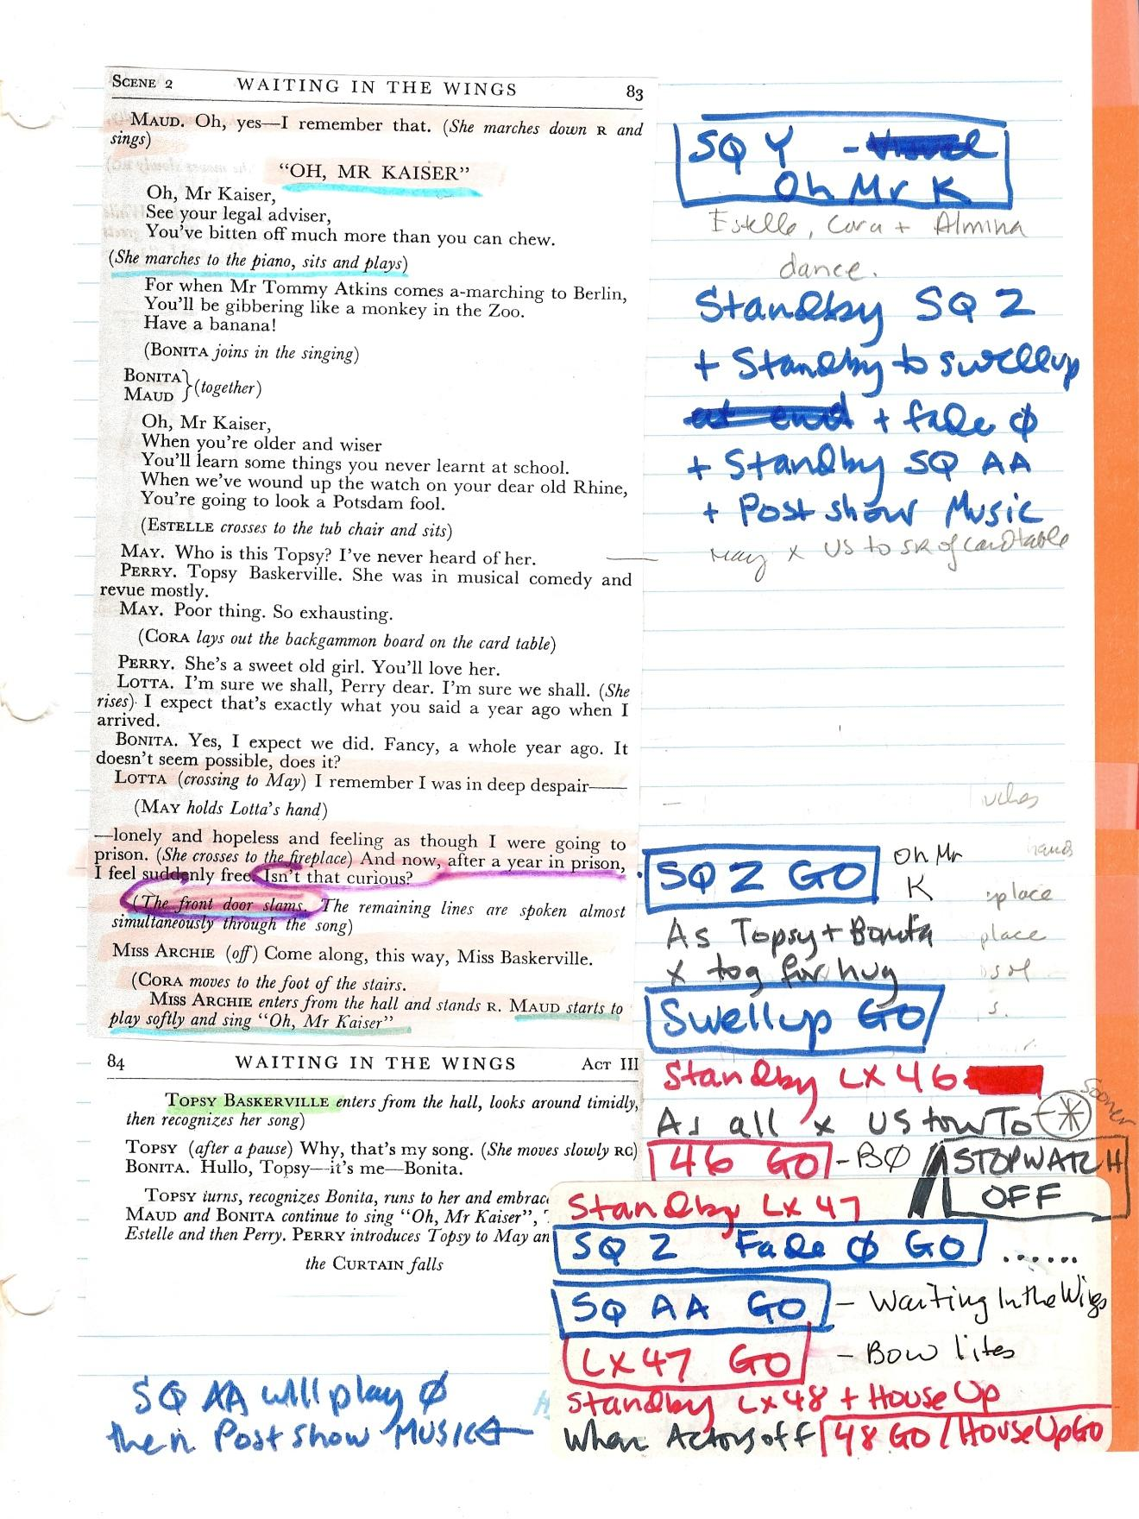

SM PRE SHOW CHECKLIST
Check in with Box Office:
- ask about size of house
- anything special about audience?
Go Downstairs:
- punch in SM code; put sign on door
- plug in kettle
- turn lights & heat on
- open up Costume Construction Room and Archival Room if they are being used for dressing
Check the Stage:
- turn on work lights and check wings
Open the Booth:
- follow the booth checklist (posted in the booth)
- make sure windows are closed
Check with Lighting Board Op:
- LX Lamp check
Check with Sound Board Op:
- Sound check to be done before house in
- Projector check to be done before house in
Check with ASM(s):
- Set and props preset ready?
House Manager:
- discuss who will give signal to let house in
- discuss Preshow Speech - live or taped
- discuss intermission and getting audience seated again
- when will they close the Bar
- arrange for coffee to be taken to Green Room

Time Calls
7:15 Give Cast & Crew the 15 minutes warning until house in
Check-in list – is everyone here?
7:25 Let cast/crew know house will be open in 5 minutes
Check that all stage work lights are off
Make sure that the Booth light and house fluorescents are off
7:30 Give go ahead to FOH Manager to let audience in
Let Cast & Crew know that the audience is being let in and 30 minutes to top of show
7:45 Give Cast and Crew the 15 minutes warning until curtain
Check with ASM(s) - are they set?
7:55 Give Cast and Crew the 5 minutes warning until curtain
7:57 Give Cast their standby for start of show
Call Standbys for opening cues
Check with ASM(s) that actors who start the show are in place
8:00 House Manager will signal that the House is ready

SM INTERMISSION CHECKLIST

Thank those on headset (Board Ops and ASM)
Confirm the time and when you expect to be back on headset
Announce that you are signing off

MAKE APPROPRIATE NOTES:
(running time of first act, etc.)

GREENROOM :
Check with Cast & Crew
Give them their 10 Minute Call
Check with ASM & Props:
Props & Stage set?

Check with House Manager

RETURN TO BOOTH:
Give Cast & Crew their 5 minute call (via paging system)
Check that Board Ops are in place

A FEW MINUTES LATER (when house is starting to move back in):
Give PLACES for Beginners
Confirm with ASM when actors in place

WHEN HOUSE IS IN AND HOUSE DOORS SHUT

STANDBY HOUSE TO ½ and all other opening cues
STOPWATCH ON

SM POST SHOW CHECKLIST
LIGHT BOARD OP:
Check that all technical duties have been completed:
- This might include hazers, fans, projectors

ASM:
Check that all technical duties have been completed:
- This might include fog machines, scrim settings, drapes, curtains, reset for the next night, etc.

CLOSE UP BOOTH
Follow Booth Checklist (posted in booth)

Check with FOH Manager re: locking up theatre
Check stage work lights are off including running lights
Check downstairs – all lights off, heat down, kettles unplugged
Punch in SM lock-out code
Remove code enabled sign from Stage Door

If someone else will be locking up:
Leave through downstairs entry door

If SM is locking up:
Turn off all lights on main floor
Check windows and doors are shut
Set alarm

OTHER
THE REHEARSAL SCHEDULE

Prior to the first rehearsal
Contact the Director and Producer to discuss the Rehearsal Schedule:
- the producer will need to be involved to book the rehearsal spaces (Rehearsal Room, Lounge, etc.) and determine dates for specific events - Meet & Greet, Publicity photos, Costume Parade, etc.
- decide who will create the Schedule and who will keep it up to date
- if possible, put it together in time to be distributed at first rehearsal
- create the schedule in a format that can be sent as an e-mail attachment or link.

At the first rehearsal
- Distribute the Rehearsal Schedule if it is available
- Ask everyone to give you dates they will be unavailable
- Hand out Detailed Emergency Info forms. Ask about allergies.
- Go over rehearsal rules

After the first rehearsal
- If a rehearsal schedule was not previously done, it should be put together following the first rehearsal
- Update as necessary based on information from cast and production team about their availability
- Send to all cast, crew and relevant theatre administration personnel.
- Make sure changes are communicated to everyone involved in the production.
- As new crew members are added, remember to send them a copy of the rehearsal schedule

OPENING AND LOCKING UP INFORMATION

Opening up:
- Key in SM Stage Door code then key in the Cast/Crew code
  - If first in building, disable alarm
  - Attach code enabled sign
- Cast and crew will use their own Stage Door code
- Turn on lights (and heat) in Rehearsal Room (if using), downstairs hallways and Green Room
- After moving to the Mainstage, you should turn on the lights (and heat) in the Dressing Rooms as well (if they’re being used this early)
Locking up during Rehearsals:
- Make sure all areas used by your production are tidy
- Check to see if you are the last one to leave the building
- If so, turn off all lights, ensure all doors and windows are properly closed
- Remove code enabled sign from Stage Door
- Set alarm
- Key in SM Stage Door code
Locking up during Performances:
- Make sure all areas used by your production are tidy
- Check with FOH Manager/Bar Manager to find out if they will be locking up. If so, make sure that all booth lights, stage work lights (including running lights) are off. Check that heat and lights are turned off downstairs; remove the code enabled sign from Stage Door and key in SM Stage Door code as you leave.
- If you will be locking up, turn off all lights, ensure all doors and windows are properly closed; remove code enabled sign from Stage Door
- Set alarm
- Key in SM Stage Door code

THE PROMPT BOOK
Examples of Prompt Books
Many Stage Managers keep prompt books from previous shows that they would be willing to lend you as an example. It is also helpful to see how other people note blocking and cues.
Building the Prompt Book begins early, and contains practically all printed elements of the production including (this list is not exhaustive):
- Script with blocking notes and technical cues
- Contact info for everyone involved in the production
- Contact info for the staff and support at the theatre
- Rehearsal schedules and scene breakdown chart
- Deadlines for all departments
- Scene change lists. (Potentially images of what the set scene should look like).
- Performance schedule with operator and crew commitments (who will be present on any given show)
[Note: Previous versions of the SM handbook had everything to do with Prompt Books here. There was no additional information from what was covered in the Handbook. If it is valuable to have this consolidated, please refer to a previous version AND let the GM know it has value.]
STAGE CREW GUIDELINES AND INFORMATION SHEET
Stage crew members include:
Props assistants -- responsible for having all props for the rehearsal ready prior to rehearsal/performance (or at the relevant point in the play). Some responsibilities include:
- props that need to be made or purchased for each rehearsal/performance, such as beverages or food to be consumed onstage
- props that need to be reset for the next rehearsal/performance, e.g., inserting blanks into a starting gun, loading a staple gun that gets used onstage, etc.
- placing props onstage in the appropriate positions at appropriate times
- when necessary, having a prop ready to hand to or retrieve from an actor backstage
- checking wear and tear of props; fixing or replacing as necessary
Stage crew/scene change crew -- responsible for shifting scenery and performing any technical jobs backstage as assigned. Responsibilities could include:
- Shifting panels, flats, large set pieces
- Adjusting drapes
- Opening and closing the main curtain
- Placing and removing (striking) furniture and props during scene changes
- Operating special effects equipment, e.g., fog machines, dry ice boxes
- Assisting actors backstage
Dressers are responsible for costumes during each performance. Usually not needed until Tech Week but sometimes will be required if there are technical problems that need to be worked out in advance.
- To provide practice time for cast with quick costume changes
- To make alterations to a costume if the quick change cannot occur in the required time

EXPECTATIONS:
- clothing requirements – wear dark long sleeve clothing (preferably black) even if not going onstage during scene changes (unless required to be in costume) and close toed shoes that are quiet
- bring own flashlight (needs to be dimmed)
- arrive at scheduled call times to be able to complete pre-show tasks
- be prepared to perform assigned tasks (pre-show, during the show and post-show) as efficiently as possible
- be aware of safety issues and learn how to operate fire-fighting equipment

